**Introduction to “R”**

**Objective:**

To perform analysis using simple scatter plot to predict the values of a desired variables

Using R studio.

**Installation of RStudio:**

URL to download RStudio (desktop versions):

<https://rstudio.com/products/rstudio/download/>

**Step1:** First click on link mentioned above and download the R (Desktop Version).To download R click here highlighted in blue color.

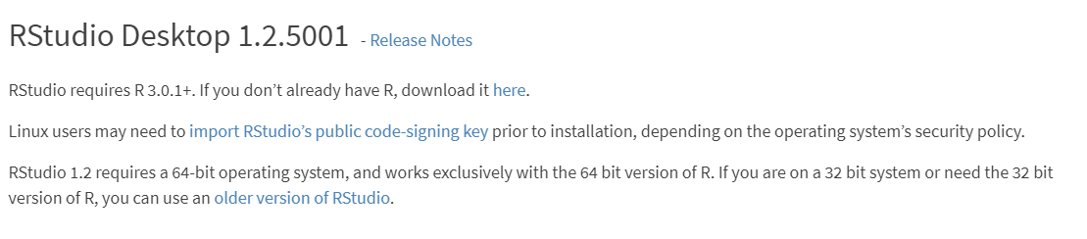

**Step2:** Click on Download R for windows

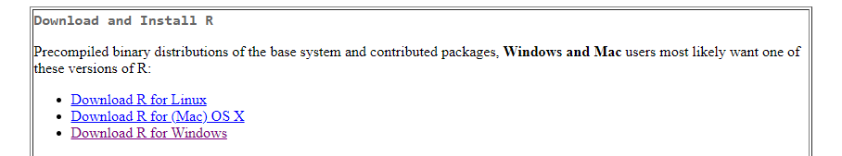

**Step3:** Then click on install R for the first time

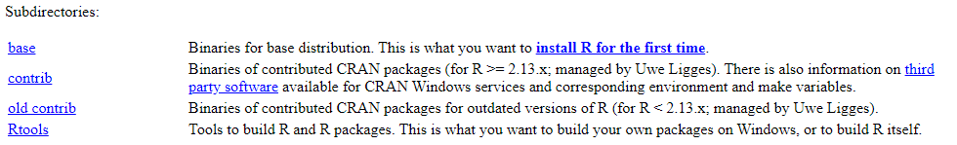

**Step4:** Click onDownload R 3.6.1 for windows

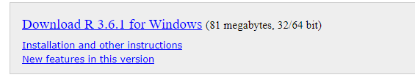

**Step5:** After downloading open the executable file and follow the installation steps



**Step6**: After downloading RStudio open the executable file and follow the installation steps

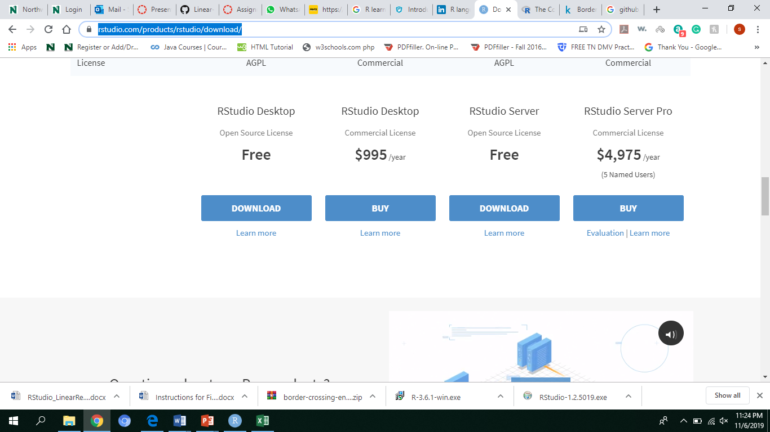

**Dataset:**



**Dataset URL:**

<https://www.kaggle.com/akhilv11/border-crossing-entry-data/data>

**Goal1:**

Goal is to get a scatter plot between the vehicle values crossing for different states.

**Steps to generate a chart:**

1. First save the excel file into your local system
2. Open RStudio and clone the code from GitHub(link is provided below)
3. Copy the code in RStudio
4. Run the code by each line based on comments mentioned in the code

**GitHub link**:

**Screenshot of generated charts:**

**Figure1:** Scatter plot on vehicles crossed for different states with their values

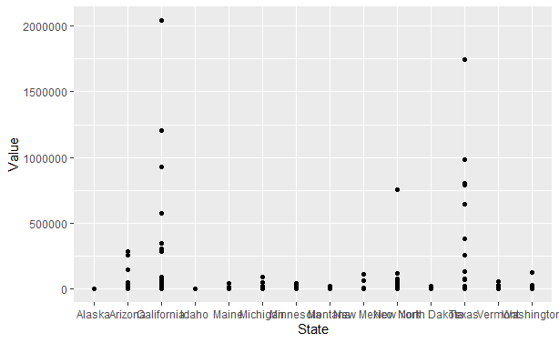

**Goal2:**

Goal is to predict vehicles crossed the border of for different vehicles

**Screenshot of generated charts:**

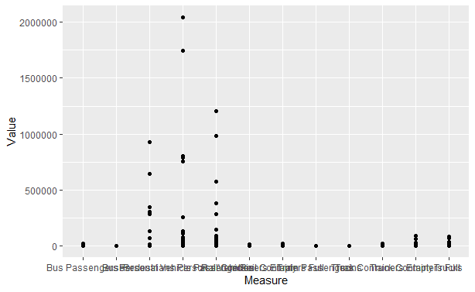

**Goal3:**

Goal is to predict the vehicles between us Mexico border and us Canada border for different vehicles.

**Screenshot of generated charts:**

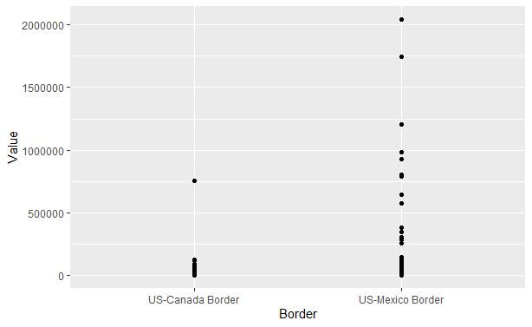

**Conclusion:**

I have tried different goals and plotted different scenarios for vehicles crossed through the borders in the past years. The different type of vehicles crossed the border. In “R” it is easy to visualize the data with more values and also it is easy to differentiate them.